Supplementary Figure S4. Clustered HGT loci in *H. dujardini* and *R. varieornatus*

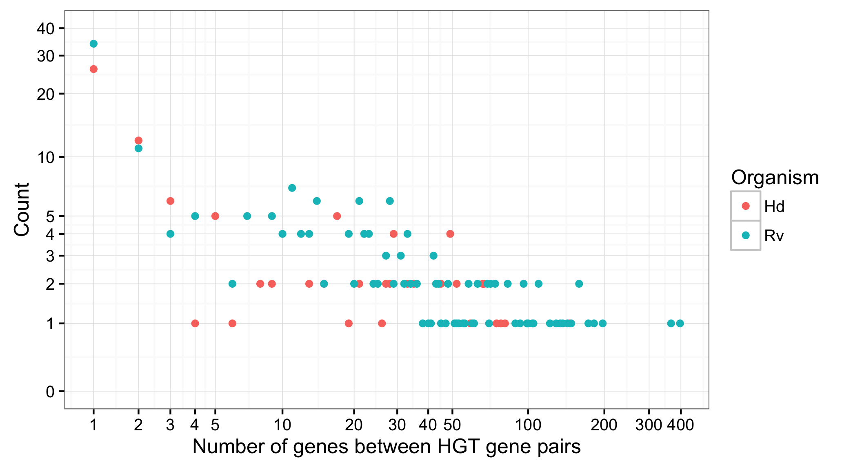

HGT candidates are clustered in the genomes of *H. dujardini* and *R. varieornatus*. The number of genes between each HGT locus was calculated, and a frequency of separations calculated. A separation of 1 indicates that the genes are neighbours. Hd=*H. dujardini*, Rv=*R. varieornatus*.